ML for Language Processing (EM40001)
Group - 16
Topic - Image-to-Text Description Generation
By

Name | Roll no.
Ayushman Mahapatra | 2330020
Shourya Basu | 2330400
Shrutik Sinha | 2330404
Manit Kumar Sahu | 2430605



Kalinga Institute of Industrial Technology
(Deemed to be University)
Bhubaneswar, India
Table of Contents
Table of Contents
Chapter 1: Problem Statement and Objectives
1.1 | Description of the Selected Problem | 1
1.2 | Motivation | 1
1.3 | Objectives | 1
1.4 | Expected Outcomes | 1
Chapter 2: Proposed Methodology and Processing Pipeline
2.1 | Block Diagram of the Processing Pipeline | 2
2.2 | Explanation of Processing Stages | 2
2.3 | Description of Input, Intermediate Processing, and Output | 4
Chapter 3: Models and Tools Used
3.1 | Machine Learning Model Used | 5
3.2 | Pretrained Model Sources | 6
3.3 | Tools and Libraries | 6
3.4 | Development Environment | 7
Chapter 4: Implementation and Usability
4.1 | Implementation Procedure | 8
4.2 | Practical Applications and Usability | 8
Chapter 5: Results and Sample Outputs
5.1 | Sample Images and Generated Descriptions | 9
5.2 | Evaluation Metrics | 11
5.3 | Comparative Performance Evaluation | 11
5.4 | Performance Analysis | 11
5.5 | Limitations of the Developed System | 12
Chapter 6: Conclusion and Future Scope |  | 13
References |  | 14
Project Resources and Repository Links |  | 15

1. Problem Statement and Objectives
1.1. Description of the Selected Problem
The project addresses the challenge of automatically generating meaningful textual descriptions from images. Understanding an image requires identifying its visual content and converting it into natural language.
To address this problem, the project implements pretrained BLIP (Bootstrapping Language-Image Pre-training) models to generate image descriptions. BLIP Base and BLIP Large are compared using standard evaluation metrics to analyse their caption-generation performance.
1.2 Motivation
The motivation behind this project is to explore the use of Artificial Intelligence in converting visual information into meaningful textual descriptions. Image captioning can reduce the effort required for manual image description and improve accessibility for visually impaired individuals. It also provides an opportunity to understand the practical application of pretrained Vision-Language Models. By implementing and comparing BLIP Base and BLIP Large, the project aims to examine how these models interpret image content and generate natural-language descriptions.
1.3 Objectives
The main objectives of the project are:
- To develop an automated image-to-text description generation system using pretrained BLIP Base and BLIP Large models.
- To process images from the MS COCO 2017 Validation Dataset and generate meaningful natural-language descriptions.
- To evaluate generated captions using BLEU-1, BLEU-2, BLEU-4, METEOR, and ROUGE-L metrics.
- To compare both models and analyse their performance, effectiveness, and limitations in image caption generation.
1.4 Expected Outcomes
The project is expected to deliver a functional system capable of generating meaningful textual descriptions from input images using pretrained BLIP Base and BLIP Large models. The generated captions are evaluated against human-written reference captions from the MS COCO 2017 Validation Dataset using standard evaluation metrics. The project also provides a comparative analysis of both models, highlighting their performance differences and demonstrating the practical application of pretrained Vision-Language Models in image understanding and natural-language generation.
2. Proposed Methodology and Processing Pipeline
The proposed system uses pretrained BLIP (Bootstrapping Language-Image Pre-training) models to generate natural-language descriptions from input images. The process involves image loading, preprocessing, visual feature extraction, and caption generation.
BLIP Base and BLIP Large are implemented using Hugging Face Transformers and evaluated on the MS COCO 2017 Validation Dataset. The generated captions are compared with human-written reference captions using standard evaluation metrics to analyse the performance of both models.
2.1 Block Diagram of the Processing Pipeline
The complete processing pipeline consists of the following stages:
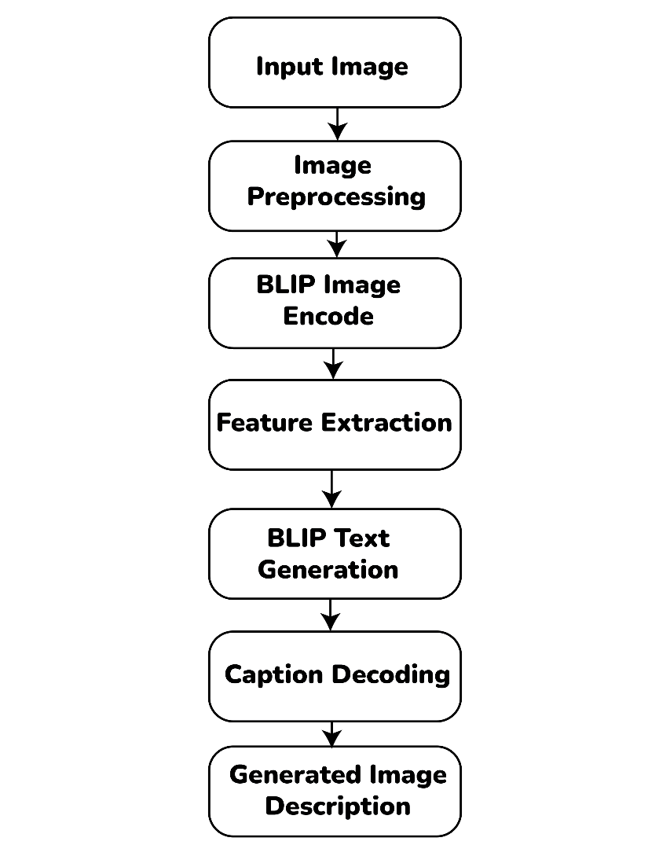
Fig – 3.1 Image-to-Text Generation by using BLIP Flowchart
2.2 Step-by-Step Explanation of Processing Stages
The proposed system follows a sequence of processing stages to convert an input image into a meaningful natural-language description. Each stage performs a specific function, from loading the image to generating and evaluating the final caption.

1. Image Input
The process begins by selecting an image from the MS COCO 2017 Validation Dataset. The selected image acts as the input to the system and contains visual information such as objects, people, activities, and surroundings that need to be described.
2. Image Loading
The selected image is loaded into the Python environment using the PIL (Pillow) library. It is converted into RGB format to ensure compatibility with the pretrained BLIP models. This prepares the image for further processing.
3. Image Preprocessing
The loaded image is passed to the BLIP processor provided by the Hugging Face Transformers library. The processor prepares the image according to the model's requirements, including resizing, normalization, and conversion into numerical tensors. These processed values are then supplied to the model.
4. Feature Extraction
The pre-processed image is passed to the BLIP Image Encoder. The encoder analyses the visual content and extracts important information, such as objects, their characteristics, and other relevant scene details. This information is converted into numerical visual features that represent the image.
5. Feature Representation
The extracted visual features are arranged into a representation that can be used by the text-generation component. This representation provides the visual context required for generating a description of the input image.
6. Caption Generation
The BLIP text-generation component uses the visual feature representation to generate a sequence of text tokens. Based on the visual information, it predicts suitable words and combines them to form a meaningful description of the image.
7. Text Decoding
The generated tokens are converted into readable natural language using the tokenizer's decoding process. Special tokens are handled, and the final caption is displayed as the textual description of the input image.
8. Performance Evaluation
After caption generation, the output is compared with human-written reference captions available in the MS COCO 2017 Validation Dataset. BLEU-1, BLEU-2, BLEU-4, METEOR, and ROUGE-L metrics are used to measure the similarity between generated and reference captions. The same evaluation procedure is applied to BLIP Base and BLIP Large to compare their performance.
2.3 Description of Input, Intermediate Processing, and Output
The system is divided into three main stages: Input, Intermediate Processing, and Output. These stages describe how an image is processed and converted into a natural-language description.
A. Input
The input consists of images selected from the MS COCO 2017 Validation Dataset, which contains 5,000 images. Each image is associated with multiple human-written reference captions. These images are provided to the BLIP models for generating descriptions.
B. Intermediate Processing
The intermediate processing stage involves preparing the image and extracting the visual information required for caption generation.
- Image Loading: The selected image is loaded using the PIL library and converted into RGB format.
- Image Preprocessing: The BLIP processor prepares the image in the required format for model input.
- Feature Extraction: The BLIP Image Encoder analyses the image and extracts relevant visual features.
- Caption Generation: The text-generation component uses the extracted visual features to generate caption tokens.
- Text Decoding: The generated tokens are converted into readable natural-language text.
C. Output
The final output is a natural-language caption describing the visual content of the input image. The system generates descriptions using both BLIP Base and BLIP Large. Their generated captions are compared with human-written reference captions using standard evaluation metrics to analyse their performance.

3. Models and Tools Used
The proposed Image-to-Text Description Generation System is based on BLIP (Bootstrapping Language-Image Pre-training), a pretrained Vision-Language Model developed by Salesforce Research. It is designed to understand visual information and generate meaningful natural-language descriptions from images.
This project focuses on implementing two pretrained versions of BLIP, BLIP Base and BLIP Large, to generate image captions and compare their performance. Both models use an image encoder to extract visual features and a text-generation component to produce descriptions. No custom model training or fine-tuning is performed.
3.1 Machine Learning Model Used
BLIP (Bootstrapping Language-Image Pre-training) is a Vision-Language Model developed by Salesforce Research. It is designed to understand visual information from images and connect it with natural language. BLIP can perform tasks such as image captioning, Visual Question Answering (VQA), and image-text matching.
In this project, BLIP is used to generate meaningful textual descriptions from input images. Two pretrained versions, BLIP Base and BLIP Large, are implemented and compared using standard evaluation metrics. Both models analyse the visual content of an image and generate a natural-language caption without requiring custom model training.
The architecture consists of an image encoder and different text-processing components. It uses three main pretraining objectives: Image-Text Contrastive Learning (ITC), Image-Text Matching (ITM), and Language Modelling (LM). Their functions are explained below.
1. Image Encoder: The image encoder uses a Vision Transformer (ViT) to process the input image. It divides the image into smaller patches and extracts visual features that represent objects, shapes, and other image details.
2. Text Encoder: The text encoder processes textual input using bidirectional self-attention. It helps the model understand the relationship between words and their context.
3. Image-Grounded Text Encoder: This component combines textual information with visual features using cross-attention. It helps the model understand how the given text relates to the contents of the image.
4. Image-Grounded Text Decoder: The decoder generates text based on the extracted image features. It uses causal self-attention to generate words sequentially and cross-attention to refer to visual information from the image.
Main Pretraining Objectives
- ITC (Image-Text Contrastive Learning): Learns to align matching image and text representations while distinguishing unrelated image-text pairs.
- ITM (Image-Text Matching): Determines whether a given text description matches the corresponding image.
- LM (Language Modelling): Generates natural-language descriptions by predicting the next word based on previously generated words and visual information.
Working in This Project
For image caption generation, the most relevant component is the Image-Grounded Text Decoder (LM). The input image is first processed by the image encoder to extract visual features. These features are then used by the decoder to generate a sequence of words. Finally, the generated tokens are converted into a readable sentence describing the image.
For example, the architecture illustrates an image of a puppy being converted into the caption "a black dachshund puppy". This demonstrates how BLIP connects visual information with natural-language generation.
3.2 Pretrained Model Sources
This project uses two pretrained versions of the BLIP image-captioning model: BLIP Base and BLIP Large. Both models are designed to analyse image content and generate natural-language descriptions.
- BLIP Base: A pretrained model used to generate image captions with a comparatively smaller model configuration.
- BLIP Large: A larger pretrained version used to generate image captions and compare its performance with BLIP Base.
Both models are implemented using the Hugging Face Transformers library and evaluated on the same MS COCO 2017 Validation Dataset using identical caption-generation settings.
3.3 Libraries and Frameworks Used
The following libraries and frameworks are used to support the implementation, image processing, pretrained model execution, and performance evaluation of the proposed system.
Technology | Purpose
Python | Primary programming language used for implementation.
PyTorch | Deep learning framework used to execute the pretrained models.
Hugging Face Transformers | Used to load the BLIP models and processor and perform caption generation.
PIL (Pillow) | Used for image loading and RGB conversion.
NumPy | Used for numerical operations and data handling.
NLTK | Used for BLEU and METEOR evaluation.
ROUGE Score | Used to calculate ROUGE-L evaluation scores.
Matplotlib | Used for displaying and visualizing images and results.

3.4 Development Environment
The project is developed using Google Colab, a cloud-based Python environment that supports GPU acceleration for executing deep learning models.
Component | Description
Platform | Google Colab
Programming Language | Python
Deep Learning Framework | PyTorch
Model Library | Hugging Face Transformers
Hardware Acceleration | NVIDIA T4 GPU, when available
Execution Mode | GPU or CPU

4. Implementation and Usability
The system is implemented using Python, PyTorch, and Hugging Face Transformers in Google Colab. It uses the MS COCO 2017 Validation Dataset to generate image descriptions through pretrained BLIP models.
Both BLIP Base and BLIP Large follow the same implementation and image-processing procedure to ensure a consistent comparison of their caption-generation performance.
4.1 Implementation Procedure
The implementation follows these steps to generate image descriptions:
1. Environment Setup: Google Colab is prepared with the required Python libraries, including PyTorch, Transformers, Pillow, NLTK, and ROUGE Score.
2. Dataset Loading: The MS COCO 2017 Validation Dataset is loaded. It contains 5,000 images with human-written reference captions.
3. Model Loading: The pretrained BLIP Base and BLIP Large models are loaded using Hugging Face Transformers.
4. Image Processing: Images are loaded using PIL, converted into RGB format, and processed using the corresponding BLIP processor.
5. Caption Generation: The processed images are passed to the BLIP model, which extracts visual features and generates image descriptions.
6. Caption Decoding: The generated tokens are converted into readable sentences and displayed as output.
7. Performance Evaluation: Generated captions from both models are compared with reference captions using BLEU-1, BLEU-2, BLEU-4, METEOR, and ROUGE-L metrics.
4.2 Practical Applications and Usability
The developed system can be useful in several areas where automatic image description is required.
1. Accessibility: Helps visually impaired individuals understand images through generated descriptions and text-to-speech systems.
2. Image Search and Retrieval: Uses generated captions to improve image searching and identification.
3. Digital Content Management: Helps describe and organize images in digital libraries and websites.
4. Education: Provides textual descriptions of images and other visual learning materials.
5. Social media and Web Applications: Helps generate image descriptions to improve content accessibility.
5. Results and Sample Outputs
This section presents sample image descriptions generated by BLIP Base and BLIP Large, followed by a comparison of their performance using standard evaluation metrics.
5.1 Sample Images and Generated Descriptions
The system was tested using images from the MS COCO 2017 Validation Dataset. Each image was processed using both pretrained models to generate natural-language descriptions.
The following examples demonstrate the caption-generation results of both models.
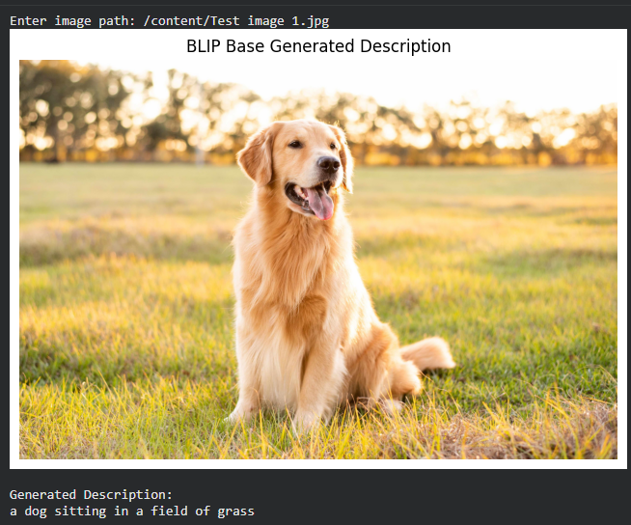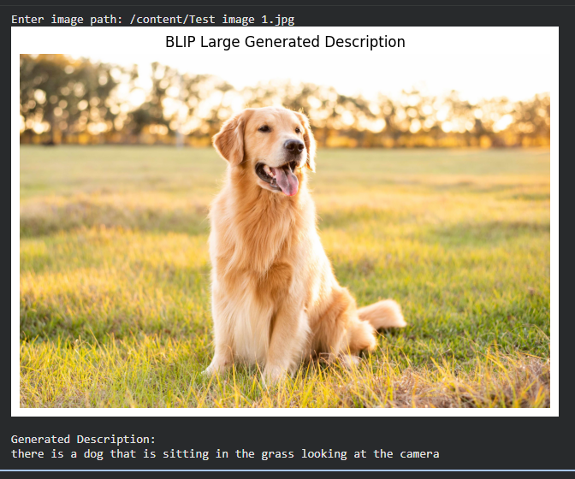
Fig 5.1. Sample Image 1 and Generated Descriptions by BLIP Base and BLIP Large.
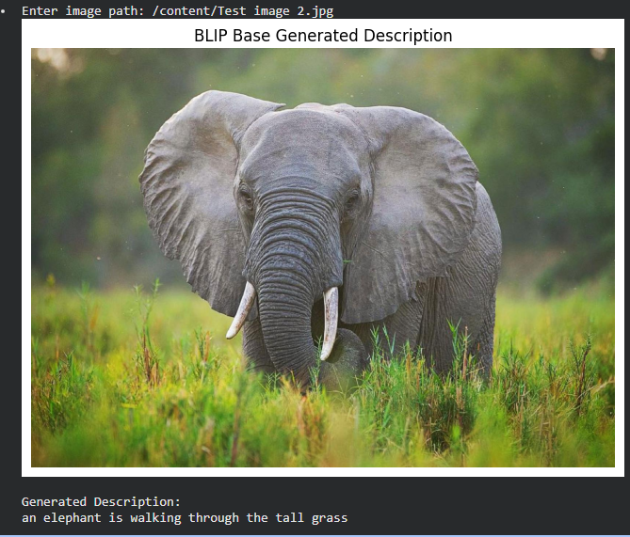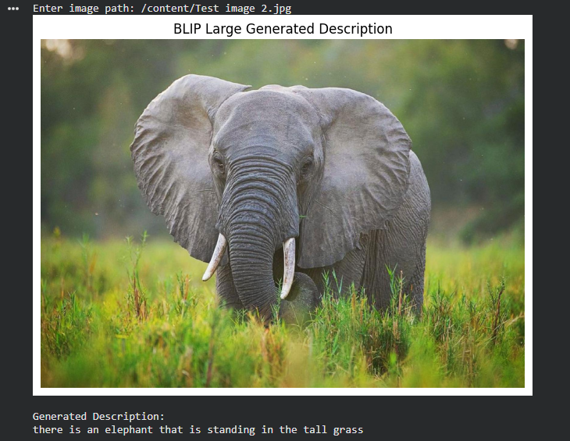
Fig 5.2. Sample Image 1 and Generated Descriptions by BLIP Base and BLIP Large.
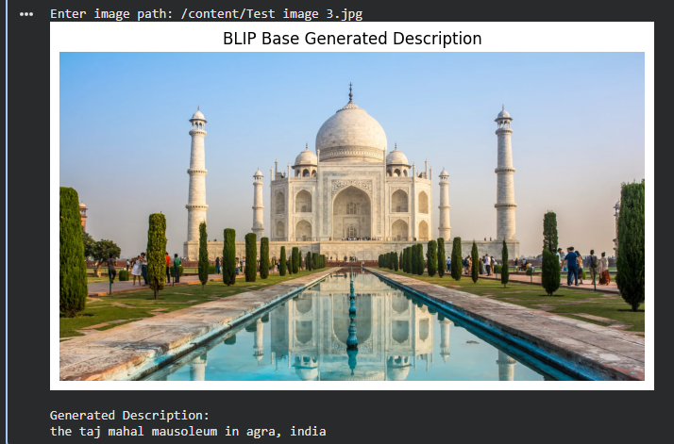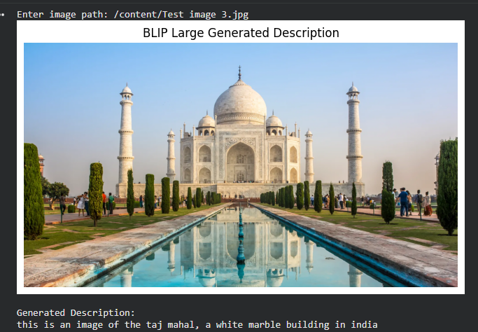
Fig 5.3. Sample Image 1 and Generated Descriptions by BLIP Base and BLIP Large.
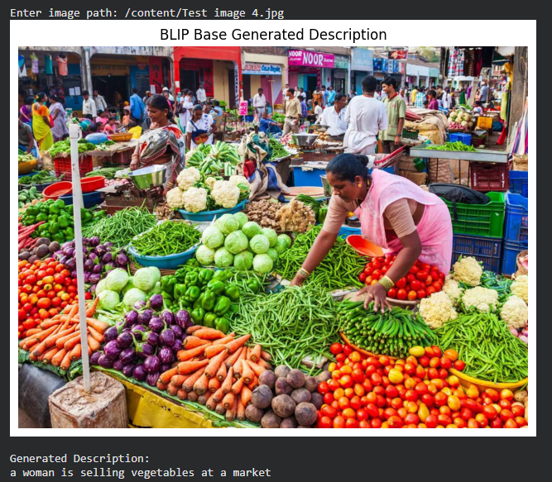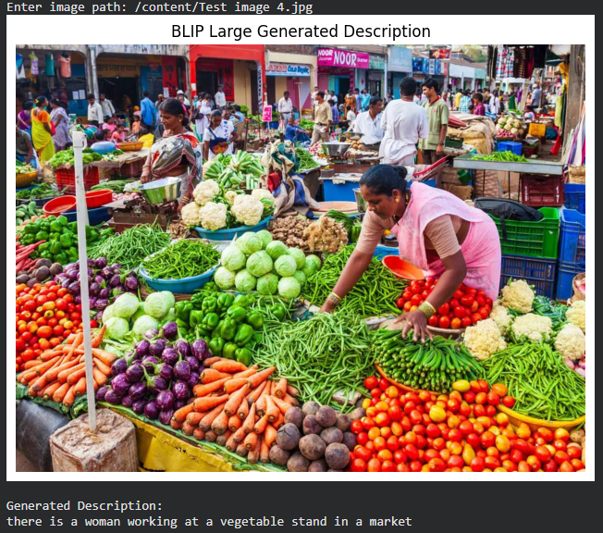
Fig 5.4. Sample Image 1 and Generated Descriptions by BLIP Base and BLIP Large.
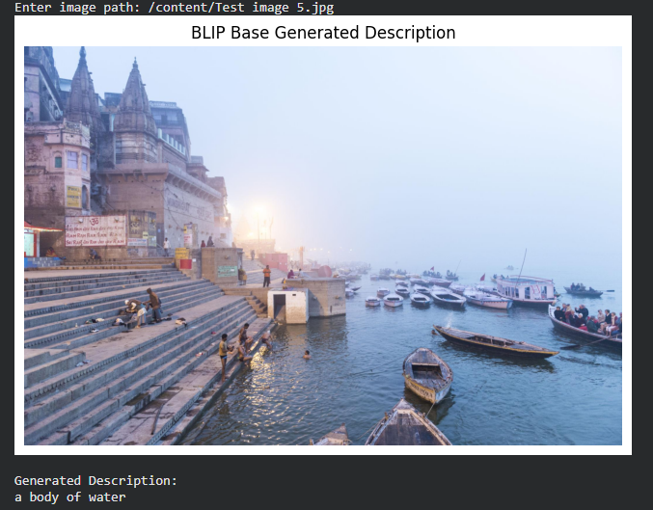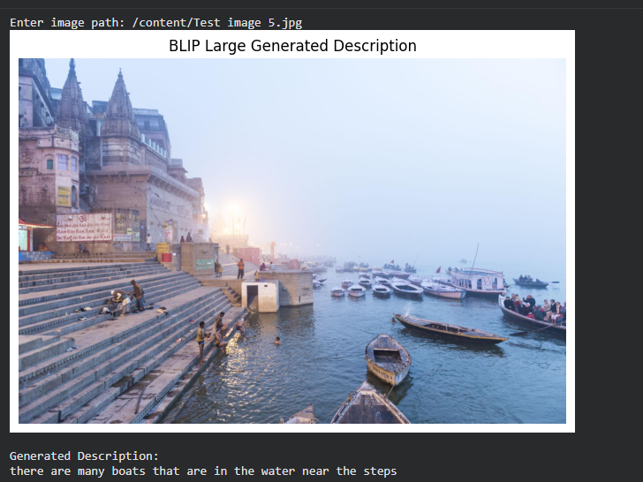
Fig 5.5. Sample Image 1 and Generated Descriptions by BLIP Base and BLIP Large.

5.2 Evaluation Metrics
The generated captions are evaluated using five standard metrics to measure their similarity to human-written reference captions.
- BLEU-1: Measures matching individual words.
- BLEU-2: Measures matching consecutive two-word sequences.
- BLEU-4: Measures matching word sequences up to four words.
- METEOR: Evaluates similarity using word-level and linguistic matching.
- ROUGE-L: Measures similarity based on the longest common subsequence.
These metrics measure caption similarity and should not be interpreted as classification accuracy.
5.3 Comparative Performance Evaluation
Both BLIP Base and BLIP Large are evaluated using the same dataset and caption-generation settings to ensure a consistent comparison.
Table 5.1: Comparative Evaluation of BLIP Base and BLIP Large
Evaluation Parameter | BLIP Base | BLIP Large
BLEU-1 | 0.6327 | 0.6763
BLEU-2 | 0.5031 | 0.5202
BLEU-4 | 0.3053 | 0.2898
METEOR | 0.4239 | 0.5284
ROUGE-L | 0.5381 | 0.5394
Average Inference Time (sec) | 0.2578 | 0.4704
Throughput (images/sec) | 3.88 | 2.13
Total Model Parameters | 223,971,600 | 446,290,500
Model Parameter Storage (MB) | 854.38 | 1,702.46
Peak GPU Memory (MB) | 1,096.56 | 1,952.90

5.4 Performance Analysis
The experimental results show the following observations:
- BLIP Large achieves higher scores in BLEU-1 and BLEU-2.
- BLIP Base performs better in BLEU-4.
- BLIP Large achieves a higher METEOR score.
- Both models achieve almost identical ROUGE-L scores.
Overall, BLIP Large performs better in four out of five evaluation metrics. However, BLIP Base achieves a higher BLEU-4 score. This indicates that model performance varies depending on the evaluation metric.

5.5 Limitations of the Developed System
Although the developed system successfully generates natural-language descriptions from images, it has certain limitations:
- Contextual Understanding: The model may not always correctly understand complex scenes, object relationships, or activities within an image.
- Caption Accuracy: Generated descriptions may occasionally omit important visual details or include incorrect information.
- Limited Description Detail: The model generally produces short captions and may not describe every object or activity present in an image.
- Dataset Dependency: The experimental evaluation is performed using the MS COCO 2017 Validation Dataset, which contains a particular range of everyday scenes and objects.
- Computational Requirements: Running pretrained deep learning models, particularly BLIP Large, may require significant computational resources.
- Evaluation Limitations: BLEU, METEOR, and ROUGE-L measure textual similarity with reference captions and may not fully represent the semantic correctness or overall quality of generated descriptions.
Overall, the experimental results demonstrate that pretrained BLIP models can effectively perform image-to-text description generation. BLIP Large achieves better results across four evaluation metrics, while BLIP Base performs better in BLEU-4. The comparison provides a practical understanding of the capabilities and limitations of pretrained Vision-Language Models.

6. Conclusion and Future Scope
6.1 Conclusion
The project, Image-to-Text Description Generation Using BLIP, successfully demonstrates the application of pretrained Vision-Language Models for automatically generating natural-language descriptions from images. The system combines Computer Vision and Natural Language Processing to analyse visual information and convert it into meaningful textual descriptions.
Two pretrained models, BLIP Base and BLIP Large, were implemented using Python, PyTorch, and Hugging Face Transformers. The MS COCO 2017 Validation Dataset, consisting of 5,000 images, was used for experimental evaluation. Both models followed the same image preprocessing and caption-generation procedure to ensure a consistent comparison.
The generated captions were evaluated using BLEU-1, BLEU-2, BLEU-4, METEOR, and ROUGE-L metrics. The experimental results showed that BLIP Large achieved better scores in four out of five evaluation metrics, while BLIP Base achieved a higher BLEU-4 score.
Through this project, the practical capabilities of pretrained Vision-Language Models in understanding visual content and generating textual descriptions were explored. The implementation also provided practical experience in deep learning, image processing, pretrained model integration, and performance evaluation.
Overall, the project demonstrates that BLIP provides an effective approach to image-to-text description generation and highlights the potential of Vision-Language Models in real-world applications.
6.2 Future Scope
The system can be improved and extended in the following areas:
1. Web and Mobile Application: Develop applications that allow users to upload or capture images and generate descriptions.
2. Real-Time Captioning: Extend the system to generate descriptions from live camera feeds and video frames.
3. Multilingual Support: Generate image descriptions in multiple languages.
4. Improved Model and Accessibility: Explore advanced Vision-Language Models and integrate text-to-speech functionality to improve caption quality and accessibility.
5. Model Optimization: Reduce computational requirements to make the system suitable for resource-constrained devices.

References
[1] J. Li, D. Li, C. Xiong, and S. Hoi, "BLIP: Bootstrapping Language-Image Pre-training for Unified Vision-Language Understanding and Generation," in Proc. 39th Int. Conf. Mach. Learn. (ICML), vol. 162, 2022, pp. 12888–12900.
[2] T.-Y. Lin et al., "Microsoft COCO: Common Objects in Context," in Proc. Eur. Conf. Compute. Vis. (ECCV), 2014, pp. 740–755.
[3] Salesforce Research, "BLIP Image Captioning Base Model," Hugging Face. [Online]. Available: https://huggingface.co/Salesforce/blip-image-captioning-base
[4] Salesforce Research, "BLIP Image Captioning Large Model," Hugging Face. [Online]. Available: https://huggingface.co/Salesforce/blip-image-captioning-large
[5] Salesforce Research, "BLIP: Bootstrapping Language-Image Pre-training," GitHub Repository. [Online]. Available: https://github.com/salesforce/BLIP
[6] PyTorch Foundation, "PyTorch Documentation." [Online]. Available: https://pytorch.org/docs/stable/
[7] Hugging Face, "Transformers Documentation." [Online]. Available: https://huggingface.co/docs/transformers/
[8] Python Software Foundation, "Python Documentation." [Online]. Available: https://docs.python.org/3/
[9] A. A. Rahman et al., "NLTK: The Natural Language Toolkit," [Online]. Available: https://www.nltk.org/
[10] Pillow Contributors, "Pillow Documentation." [Online]. Available: https://pillow.readthedocs.io/

Project Resources and Repository Links
The following table provides access to the dataset, source code, implementation video, and other project resources.
Resource | Link
Dataset | MS COCO 2017 Validation Dataset
GitHub Repository | https://github.com/Shourya-Basu/Image-to-Text_Description_Generation.git
Project Demonstration Video | https://youtu.be/0f6SnVhzlEM
BLIP Base Model | Hugging Face Link
BLIP Large Model | Hugging Face Link

